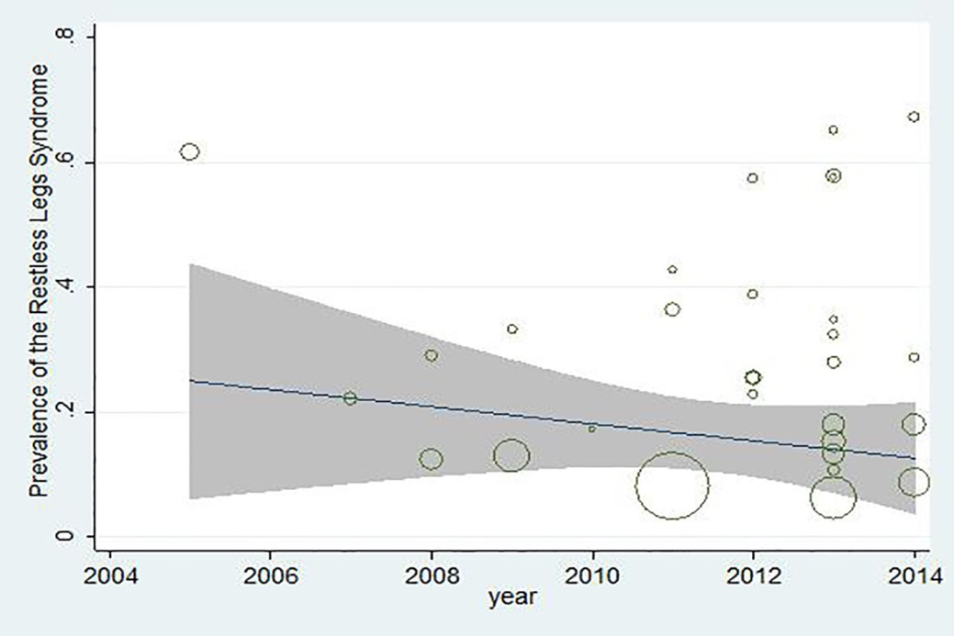
Figure (3): The meta- regression diagram of the RLS prevalence, based on the year of conduct study. The greater circle shows the greater sample size’s number.

