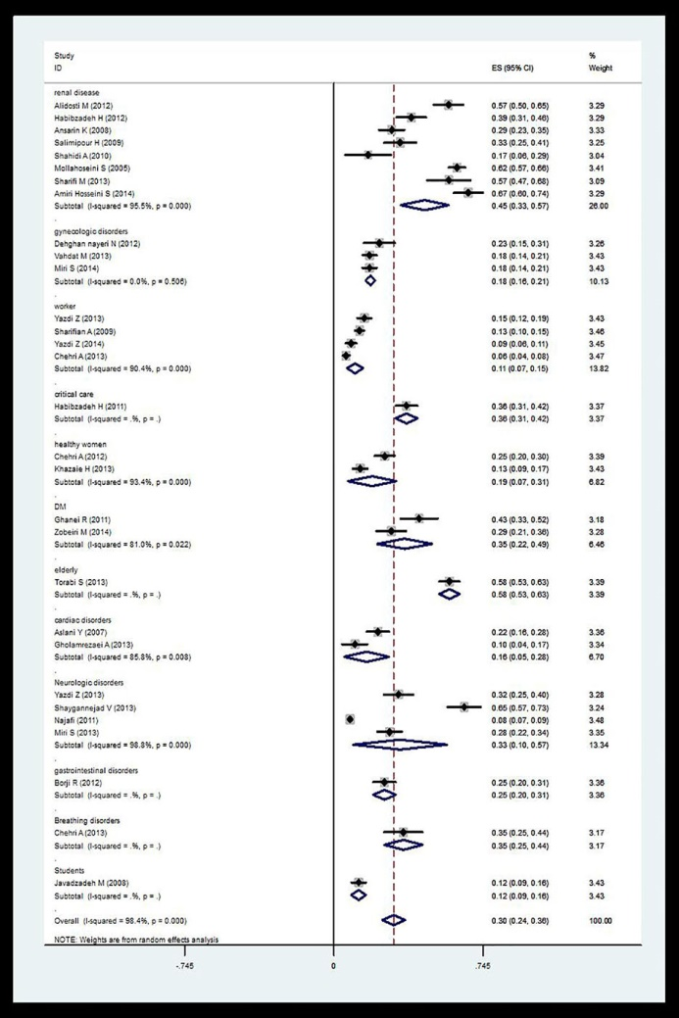
Figure (2): The prevalence of RLS based on the target population variable by the performed studies in the country. 95% Confidence interval for each study as horizontal lines around the main mean and the dotted line in the middle show, the estimated total prevalence and the lozenge show the confidence interval of the total prevalence.

