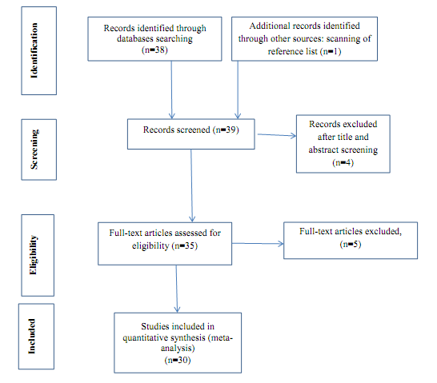
Figure (1): Studies’ entry procedure to systematic review and Meta-analysis flowchart based on PRISMA guideline.

